**PROGRAM 1**

**Design a Static webpage using HTML tags.**

CODE’

<!DOCTYPE html>

<html lang="en">

<head>

<meta charset="UTF-8">

<meta name="viewport" content="width=device-width, initial-scale=1.0">

<title>My Static Web Page</title>

<style>

body {

font-family: Arial, sans-serif;

margin: 20px;

padding: 20px;

}

header, footer {

background-color: #02fff2;

color: #fff;

text-align: center;

padding: 10px;

}

section {

margin-top: 20px;

}

</style>

</head>

<body>

<header>

<h1>Welcome to My Web Page</h1>

</header>

<section>

<h2>About Me</h2>

<p>My name is Akhilesh Sharma</p>

</section>

<section>

<h2>My Hobbies</h2>

<ul>

<li>Reading</li>

<li>Programming</li>

<li>Traveling</li>

</ul>

</section>

<footer>

<p>My Web Page</p>

</footer>

</body>

</html>

OUTPUT

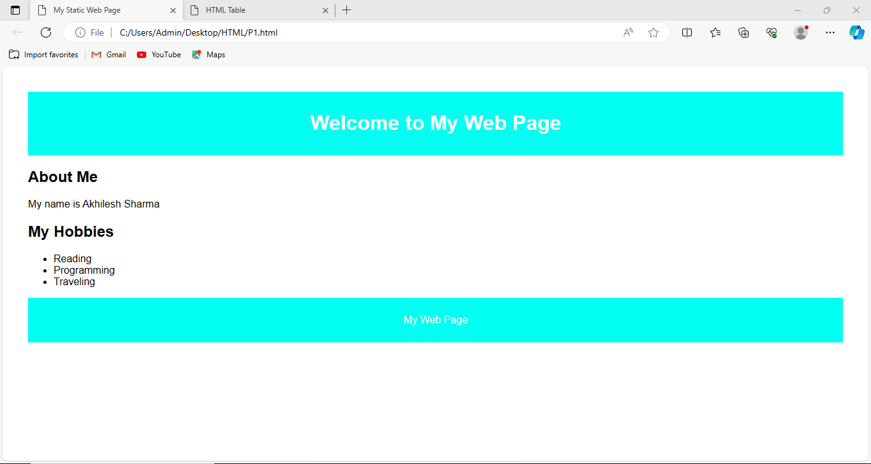

**PROGRAM 2**

**Design a Student’s table using HTML tags.**

Code

<!DOCTYPE html>

<html lang="en">

<head>

<meta charset="UTF-8">

<meta name="viewport" content="width=device-width, initial-scale=1.0">

<title>HTML Table</title>

<style>

table {

width: 100%;

border-collapse: collapse;

margin-top: 20px;

}

th, td {

border: 1px solid #0a0a0a;

padding: 8px;

text-align: left;

}

th {

background-color: #10e7ee;

}

</style>

</head>

<body>

<h2>STUDENT TABLE</h2>

<table>

<thead>

<tr>

<th>Sr.No</th>

<th>Name</th>

<th>Age</th>

<th>City</th>

<th>DOB</th>

<th>Contact No.</th>

</tr>

</thead>

<tbody>

<tr>

<td>1</td>

<td>Akhilesh Sharma</td>

<td>17</td>

<td>Moradabad</td>

<td>05/12/2005</td>

<td>7668614225</td>

</tr>

<tr>

<td>2</td>

<td>Aniket Singh</td>

<td>18</td>

<td>Moradabad</td>

<td>12/02/2005</td>

<td>9411623765</td>

</tr>

<tr>

<td>3</td>

<td>Piyush Chauhan</td>

<td>18</td>

<td>Moradabad</td>

<td>17/05/2005</td>

<td>6397163256</td>

</tr>

<tr>

<td>4</td>

<td>Kaushal Sharma</td>

<td>18</td>

<td>Moradabad</td>

<td>18/07/2004</td>

<td>9389463924</td>

</tr>

<tr>

<td>5</td>

<td>Abhishek Chauhan</td>

<td>18</td>

<td>Moradabad</td>

<td>19/12/2005</td>

<td>9758242898</td>

</tr>

<tr>

<td>6</td>

<td>Yash Kumar</td>

<td>17</td>

<td>Moradabad</td>

<td>12/12/2005</td>

<td>6397460024</td>

</tr>

<tr>

<td>7</td>

<td>Arpit </td>

<td>19</td>

<td>Moradabad</td>

<td>25/08/2004</td>

<td>9760622385</td>

</tr>

<tr>

<td>8</td>

<td>Haris Khan</td>

<td>23</td>

<td>Rampur</td>

<td>20/12/2000</td>

<td>7456918026</td>

</tr>

<tr>

<td>9</td>

<td>Akhilesh Kumar</td>

<td>21</td>

<td>Rampur</td>

<td>05/05/2002</td>

<td>9389645959</td>

</tr>

<tr>

<td>10</td>

<td>Arwaz Alam</td>

<td>23</td>

<td>Kundarki</td>

<td>08/10/2000</td>

<td>6397181174</td>

</tr>

</tbody>

</table>

</body>

</html>

OUTPUT

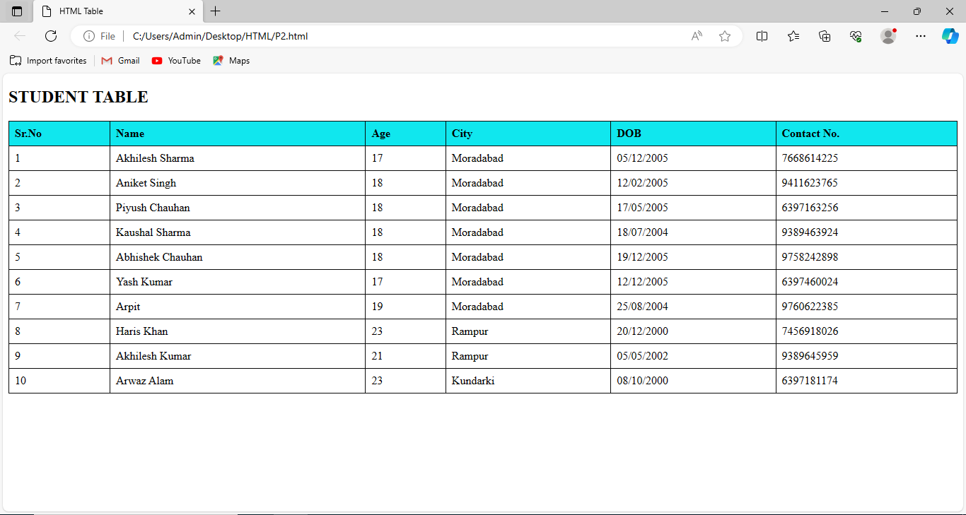

**PROGRAM 3**

**Design a static homepage in HTML using frames.**

CODE

<!DOCTYPE html>

<html>

<frameset rows="15%,9%,76%" border="4" solid

blanchalmond>

<frameset cols="20%,80%" border="4" solid

blanchedalmond>

<frame src="logo.html" scrolling="no">

<frame src="title.html" scrolling="no">

</frameset>

<frame src="menu.html" name="f3" scrolling="no">

<frameset cols="16%,85%" border="4" border color="Red">

<frame src="branches.html" name="f37" scrolling="no">

<frame src="home.html" name="f38" scrolling="no">

</frameset>

</frameset>

OUTPUT

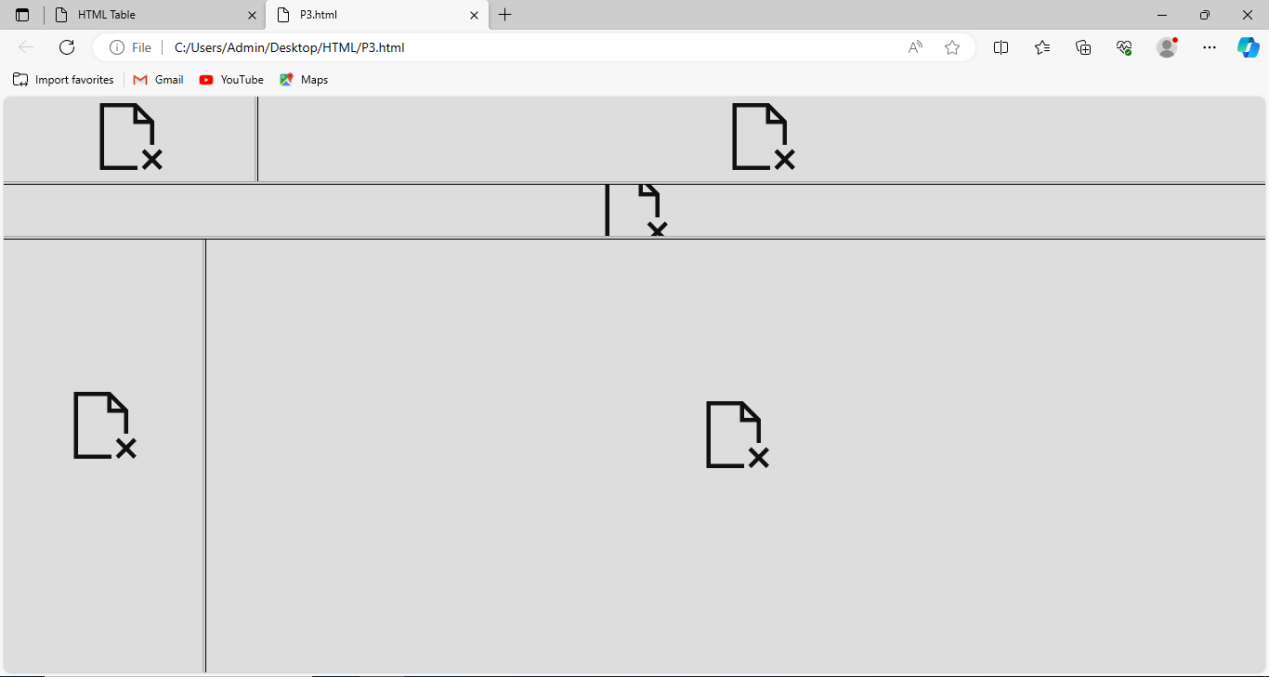

**PROGRAM 4**

**Design a Login page using HTML and CSS.**

Code

<!DOCTYPE html>

<html lang="en">

<head>

<meta charset="UTF-8">

<meta name="viewport" content="width=device-width,

initial-scale=1.0">

<title>Login Page</title>

<style>

body {

display: flex;

align-items: center;

justify-content: center;

height: 100vh;

margin: 0;

background-color: #f1f1f1;

}

.login-container {

background-color: #fff;

border-radius: 8px;

box-shadow: 0 0 10px rgba(0, 0, 0, 0.1);

padding: 20px;

width: 300px;

}

.login-form {

display: flex;

flex-direction: column;

}

h2 {

text-align: center;

color: #333;

}

label {

margin-top: 10px;

color: #555;

}

input {

padding: 8px;

margin: 5px 0 15px 0;

border: 1px solid #ccc;

border-radius: 4px;

}

button {

background-color: #4caf50;

color: #fff;

padding: 10px;

border: none;

border-radius: 4px;

cursor: pointer;

}

button:hover {

background-color: #45a049;

}

</style>

</head>

<body>

<div class="login-container">

<form class="login-form">

<h2>Login</h2>

<label for="username">Username:</label>

<input type="text" id="username" name="username"

required>

<label for="password">Password:</label>

<input type="password" id="password" name="password"

required>

<button type="submit">Login</button>

</form>

</div>

</body>

</html>

Output

